FOR MORE INFORMATION, TO PURCHASE TICKETS, OR TO DONATE TOWARDS THE RAFFLE, PLEASE VISIT
https://ghs-sunset-cruise.cheddarup.com
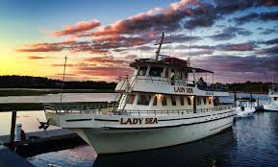
- Current Coaches and Families
- Former Players & Coaches
- Friends of the Program

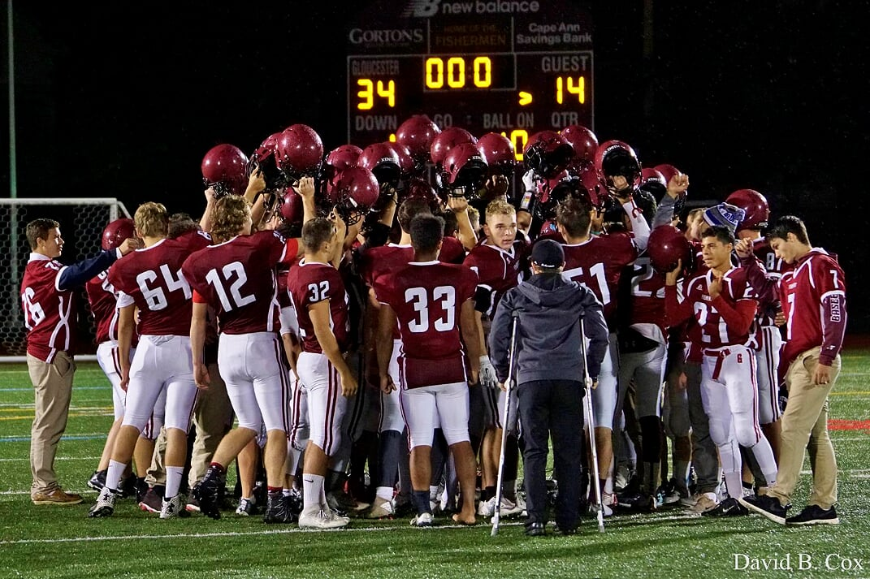
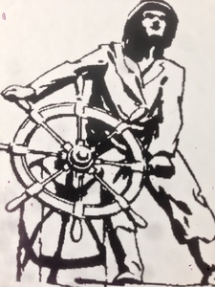
KICK OFF THE SUMMER
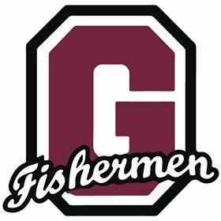
$25 TICKETS
RAFFLE PRIZES AND ENTERTAINMENT with DJ AUSTIN SOUSA
SAT JUNE 15th
7pm-10 pm.
SUNSET HARBOR CRUISE (21+) WITH THE GLOUCESTER FLEET ON BOARD THE LADY SEA @ CAPE ANN MARINA
WITH THE
GHS FOOTBALL PROGRAM

